**JavaScript**

* JavaScript is an interpreted programming language while Java is a compiled language.

JavaScript Alerts

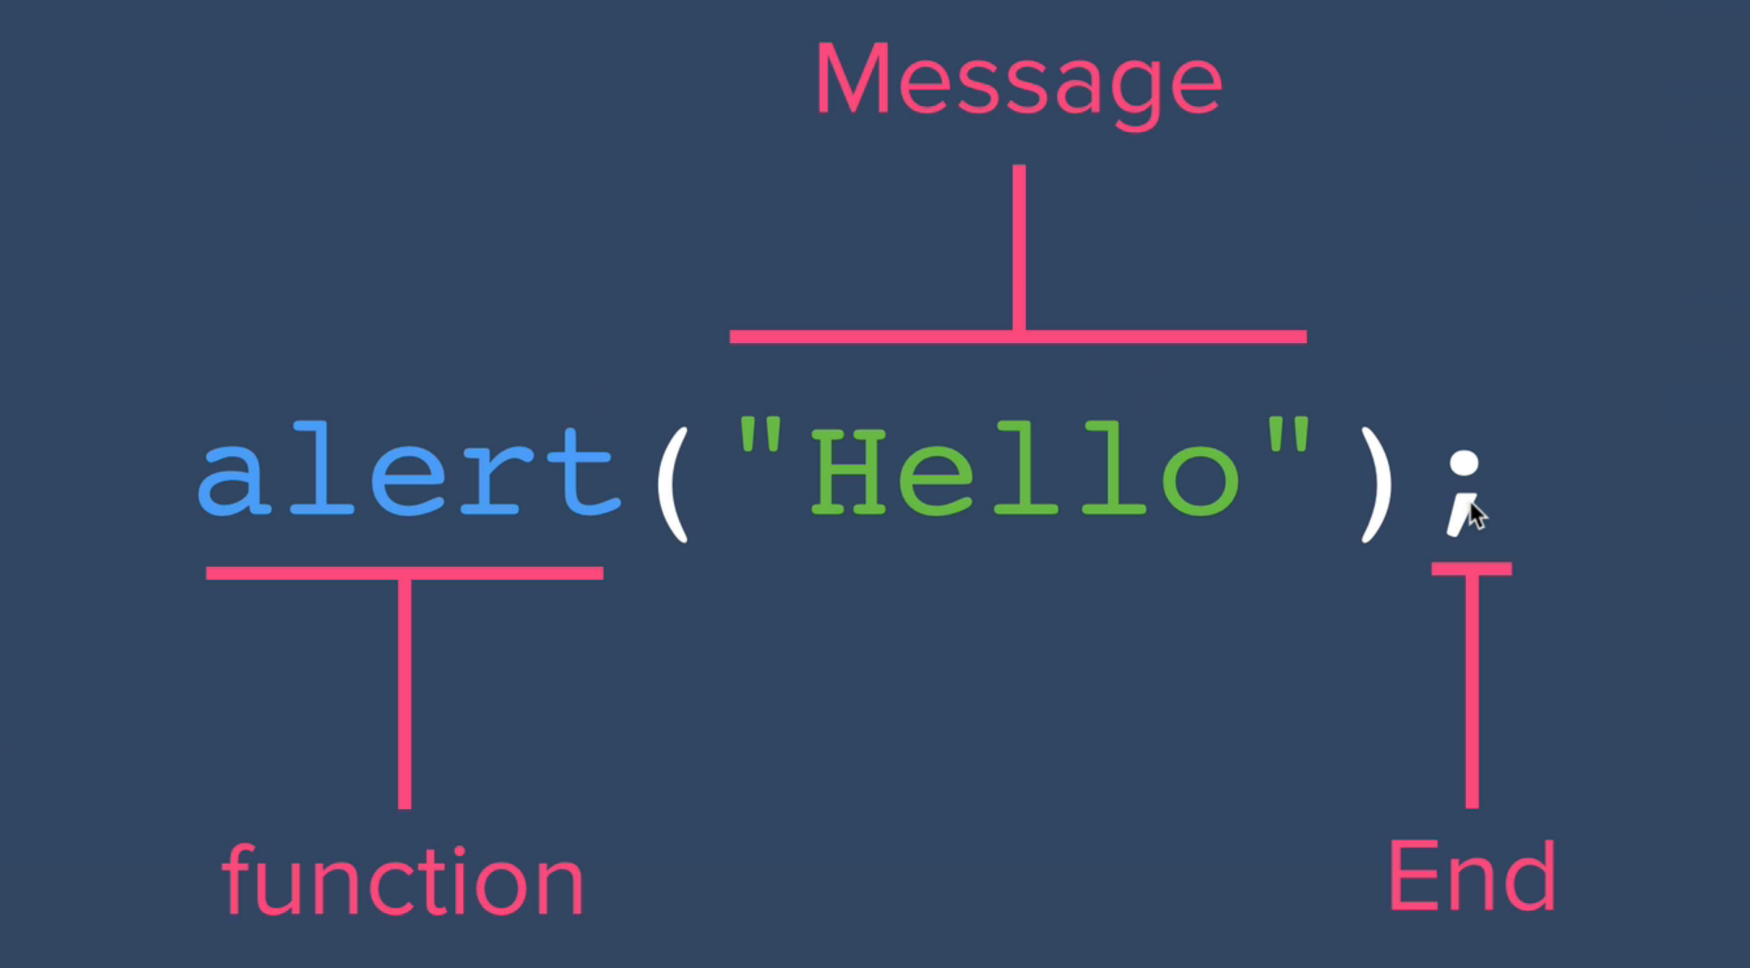

* Alert is also known as ‘function’.
* The typeof(…) function tells the data of the element enclosed within the parenthesis.

JavaScript Data-types

* It is a way of classifying the data to telling the computer how the program intends to use the data.

e.g., strings (“Hello”) 🡪 these are texts that are not meant to be interpreted as data.

* Other data-types: numbers, Boolean.

JavaScript Variables

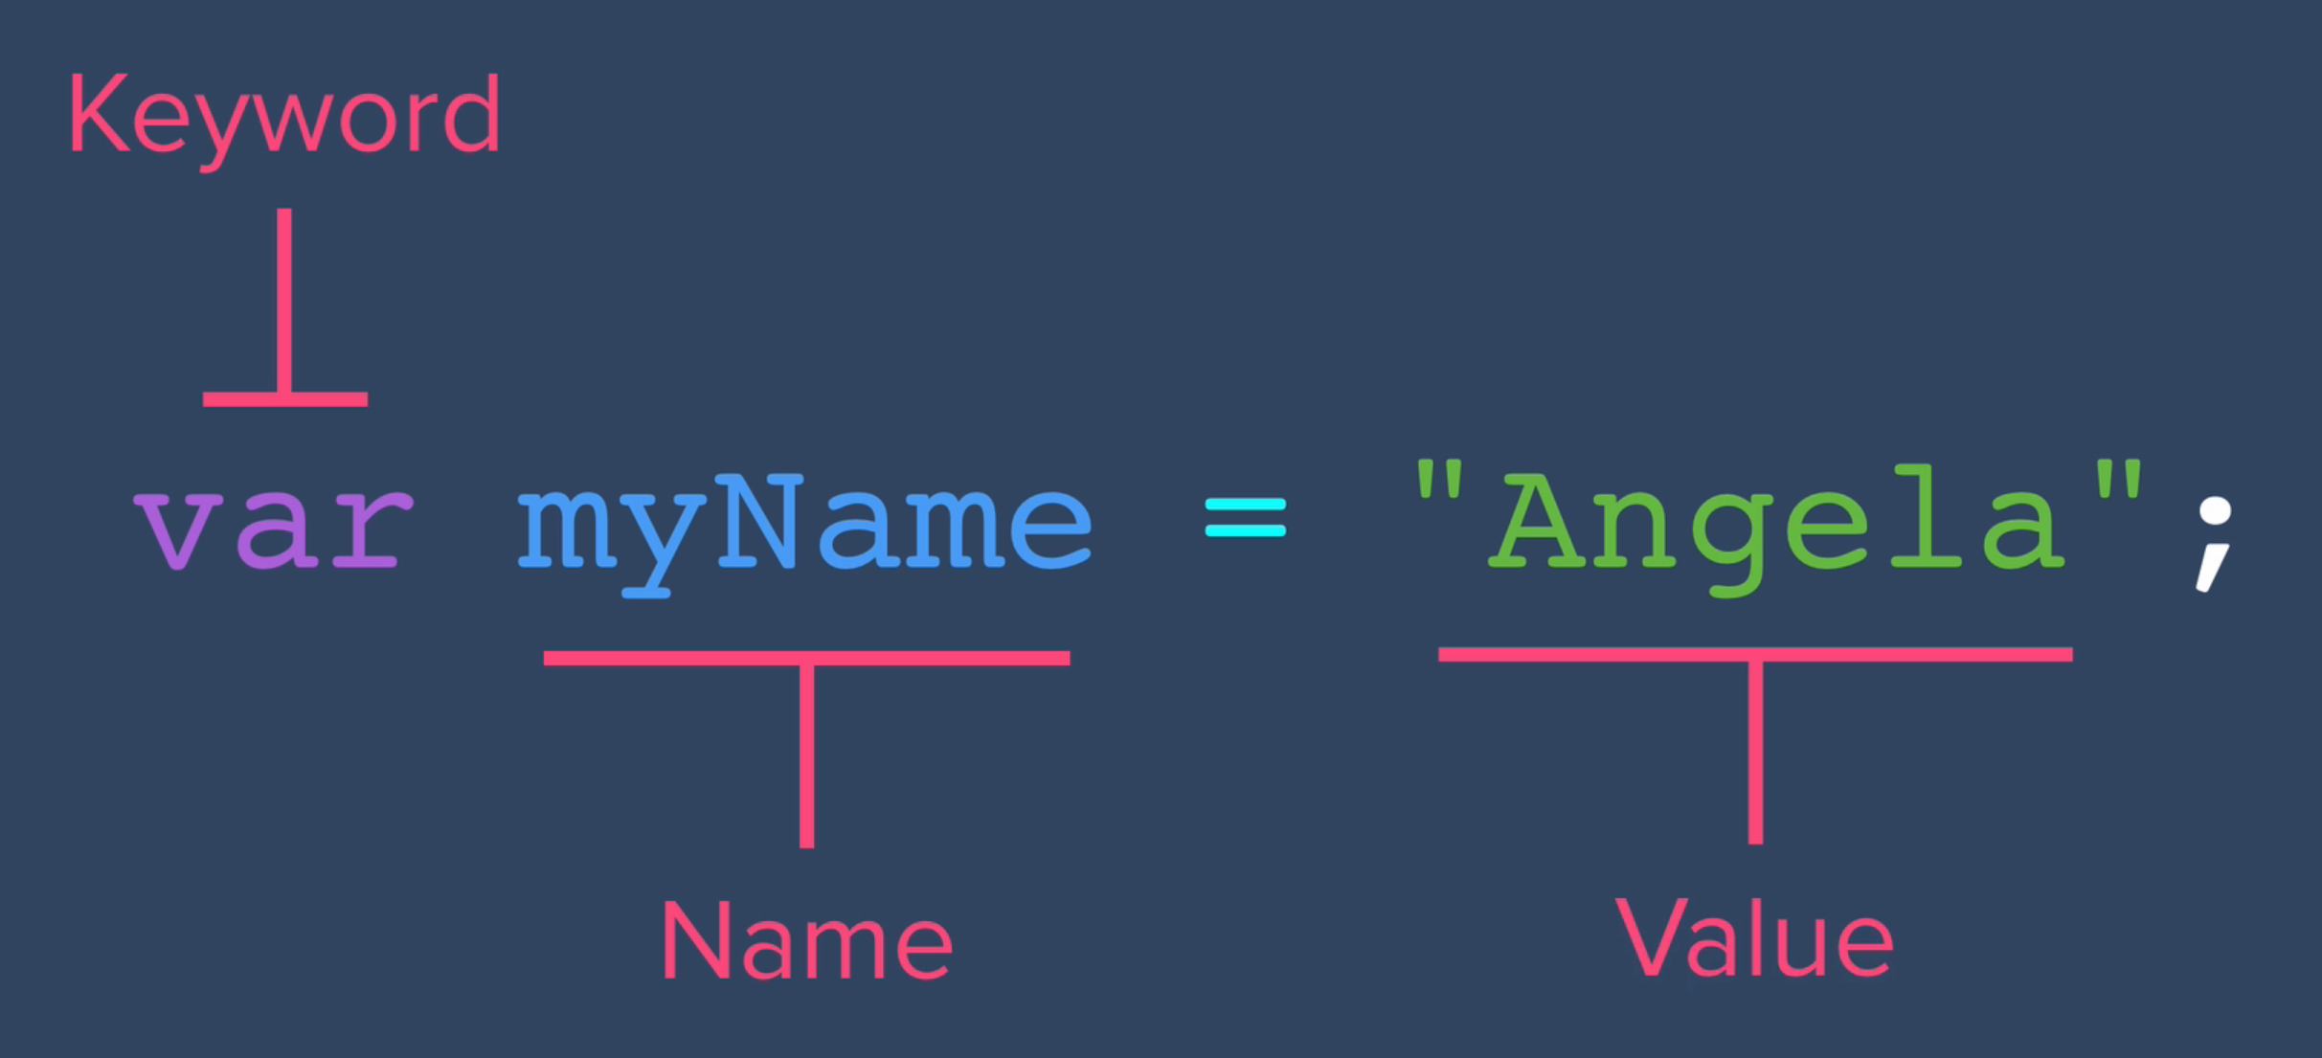

Variables Naming Convention in JavaScript

* A variable can’t start with spaces.
* A variable can contain only letters, numbers, $ and _.
* A variable can’t contain a space in between.
* camelCase format is generally used for best practises.

e.g., therapistFinder.com

Strings

* In JavaScript, strings are concatenated in the same way as in Java.

e.g., “Hello” + “ “ + “world”;

* word.length can be used to find the number of characters in a particular word.

e.g., name = “Junaid”

name.length = 6.

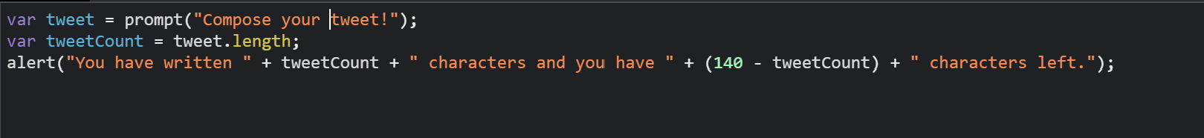

* Slice keyword can be used to get a part of the string, same as getting substring of a string.
* Syntax: variableName.slice(x, y);

Where x and y are positions (indices).

e.g., name = “Junaid”

name.slice(0, 1); 🡺 “J”

name.slice(5, 6); 🡺 “d”

* + - * 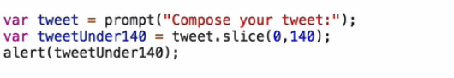
* toUpperCase() or toLowerCase() methods can be used to convert a lowercase letter to uppercase and vice-versa.
* Syntax:
  + varName.toUpperCase();

e.g.,

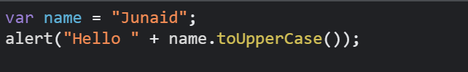

Functions in JavaScript

* In JavaScript, a function is a block of code that is designed to perform a specific task and can be executed (or "called") whenever it is needed.
* Functions allow for code reuse and can make your code more organized and readable.
* A function is declared using the "function" keyword, followed by a function name, a set of parentheses that can accept parameters, and a code block within curly braces.

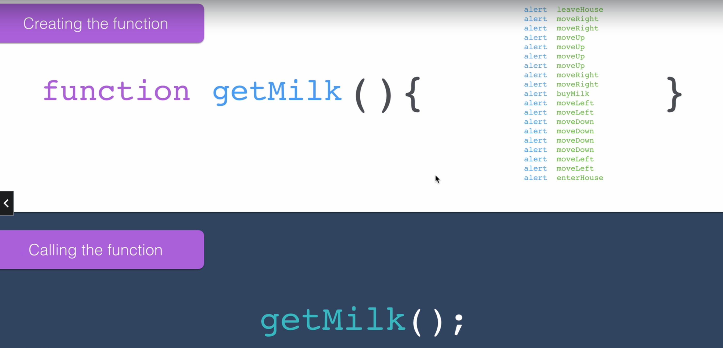

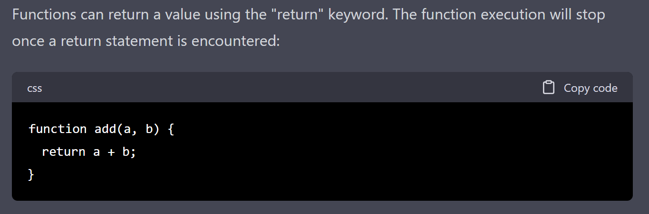

Note:

* console.log is used to print a part of the code in Console.
* We can get the floor value of a variable by using the floor() function.
* Syntax:
  + - Math.floor(var);
  + E.g., var money = 5;

Var bottles = Math.floor(5/1.5);

Console.log(bottles) = 3

Parameters and Arguments

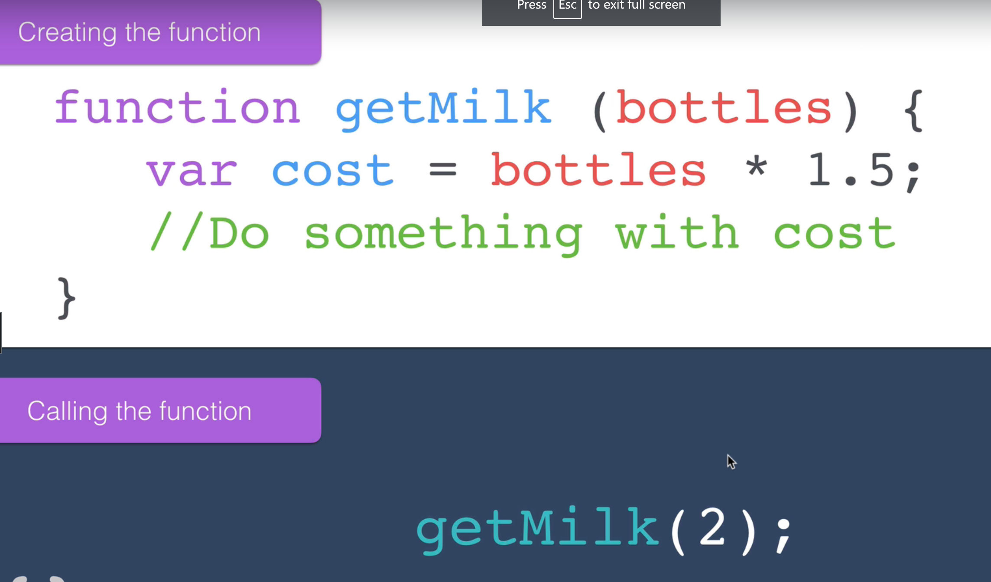

Output and Return Values

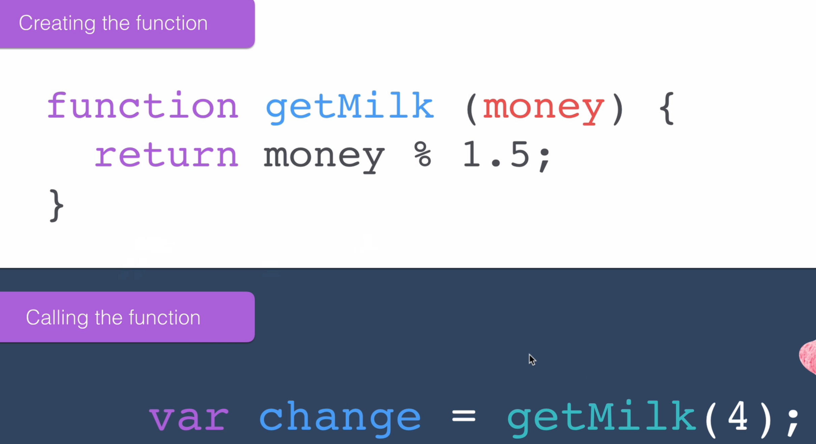

Random Number generator

* In JavaScript, we can generate random numbers using Math.random().
* The number, thus generated, always lies between 0 – 0.99999999999999999.

i.e., the number generated will be a floating number upto 16 decimal places.

Random number generator for a dice game,

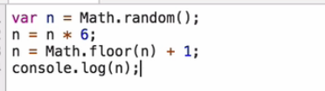

Conditionals in JavaScript (if – else)

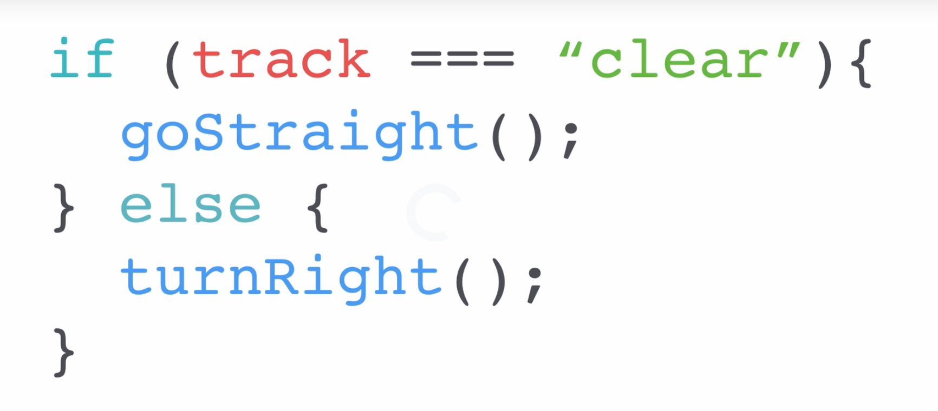

Comparators

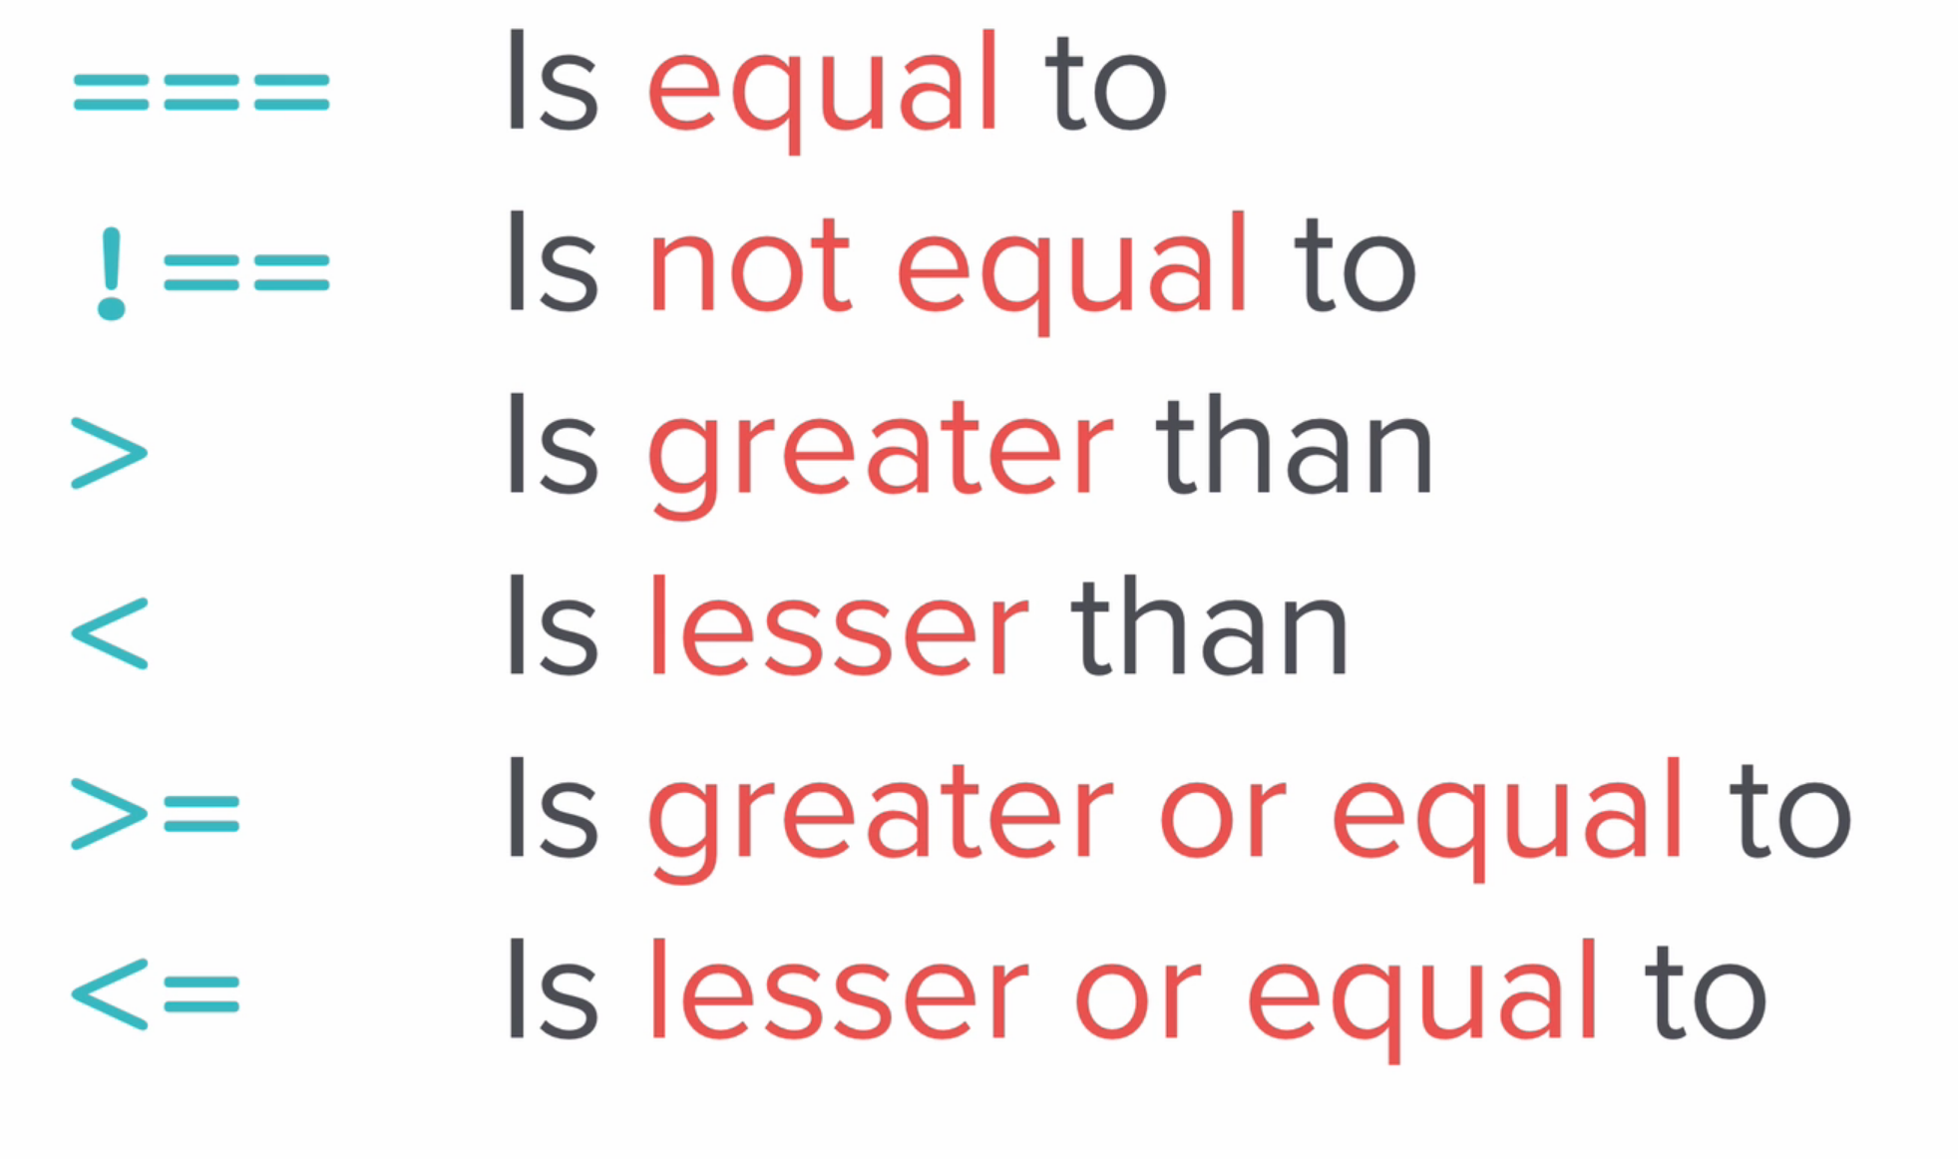 

Note:

* The comparators ( ===) and (==) both check for equality, but the first one also takes care of the data-type of the variables.
* Check for leap year,

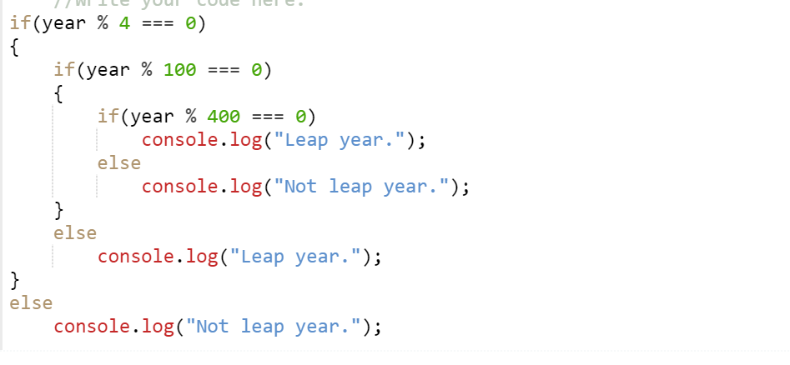

Arrays in JavaScript

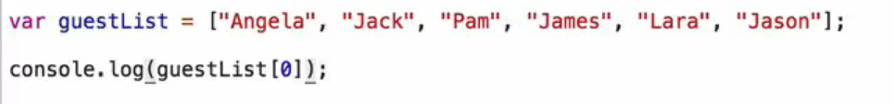

* guestlist.length() can be used to find the size of the array.
* guestlist.includes(…) can be used to find whether a particular data is present or not in the array. It returns a Boolean value.
* arrayName.push(…) is used to add an element to an array.
* arrayName.pop is used to delete an element from an array.

Note: If we print an array in JavaScript, it will always be having the array size first, followed by the content of the array.

Loops in JavaScript

While Loop for loop

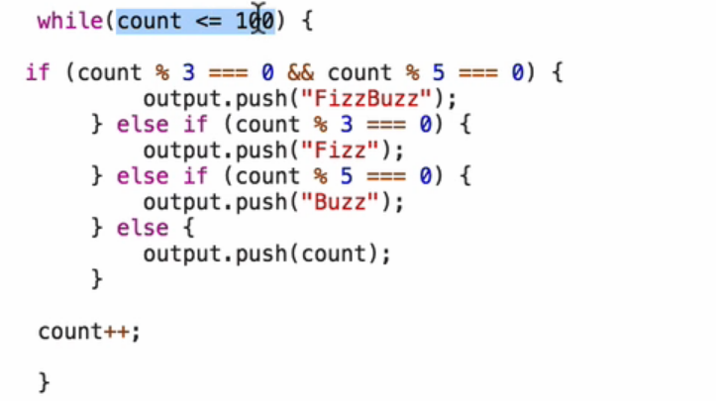 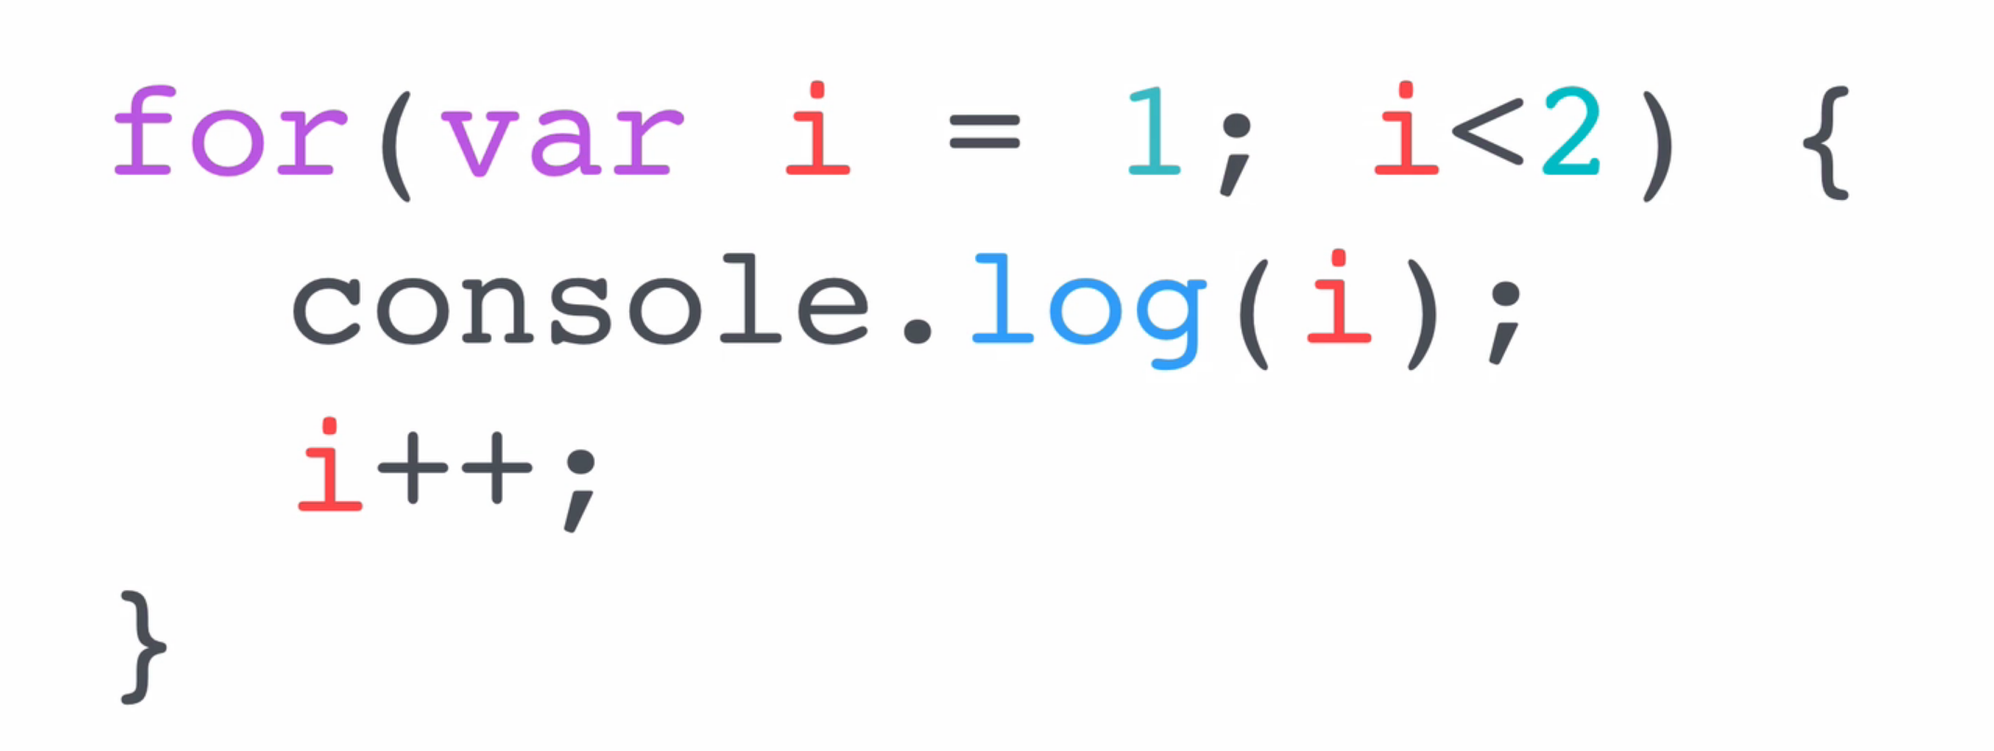

**Document Object Model**

Adding JavaScript to our websites

1. Inline JavaScript



ii. Internal JavaScript

JavaScript can be added using script tag inside the HTML file.

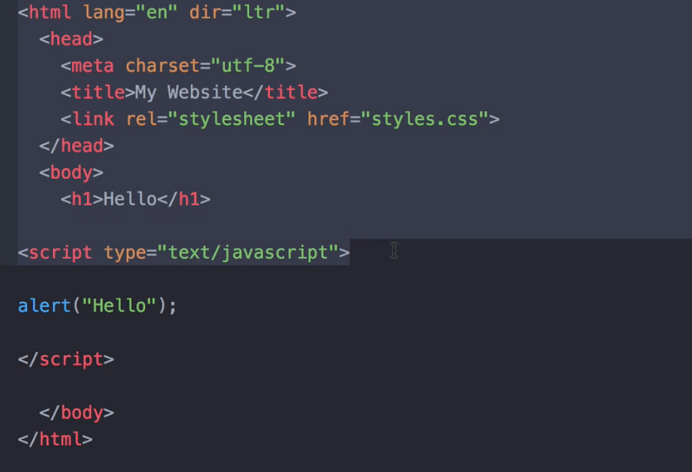

iii. External JavaScript

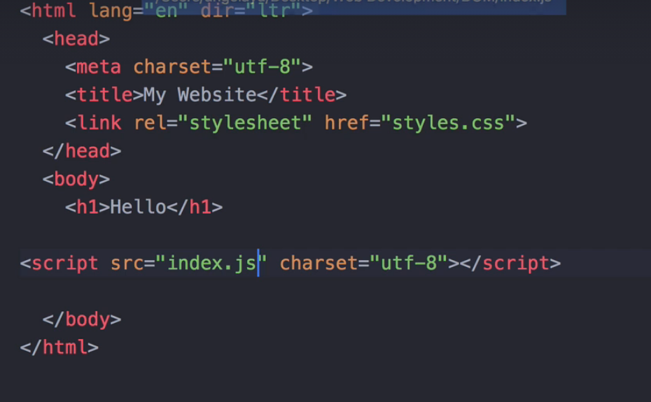

Note:

* CSS rules should be linked in the HTML before the elements on which it is supposed to be applied. That’s why, the CSS file is linked in the head section of the HTML.
* Whereas, the JavaScript should be linked after the element on which it will be applied. So, it is placed just before the end of the body tag in the HTML page.

DOM

* The Document Object Model (DOM) is a programming interface for HTML and XML documents.
* It represents the structure of a document as a tree-like structure, with elements of the document being nodes in the tree.
* JavaScript can be used to manipulate the DOM, allowing you to change the structure, style, and content of a web page dynamically.
* By using JavaScript to interact with the DOM, you can create dynamic web pages that respond to user interaction and update themselves automatically.

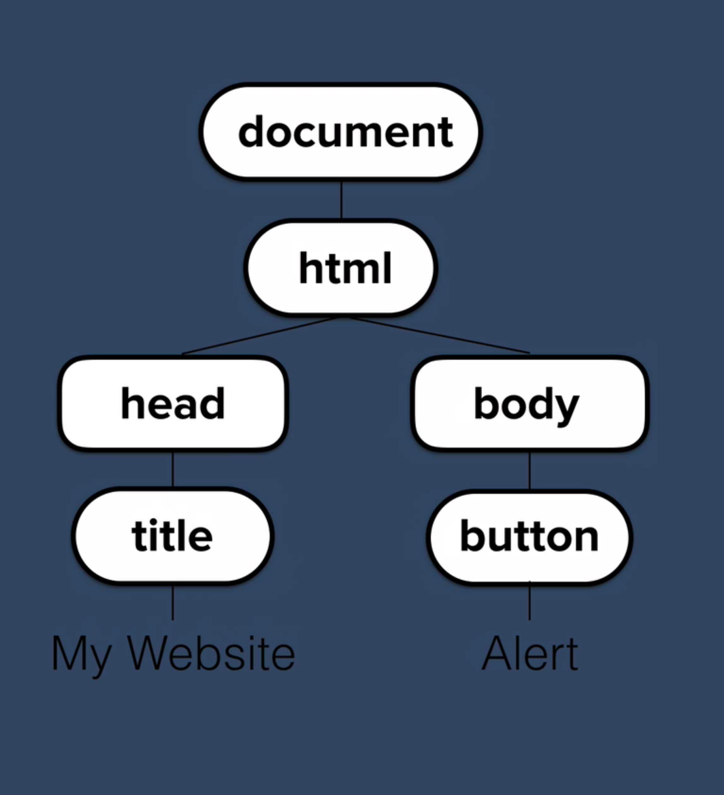

Get property: by using dot notation

Car.color; // red

Set Property: by simply assigning a value

Car.numberOfDoors = 2;

Call Methods:

Car.drive(); // car starts driving

Button Object

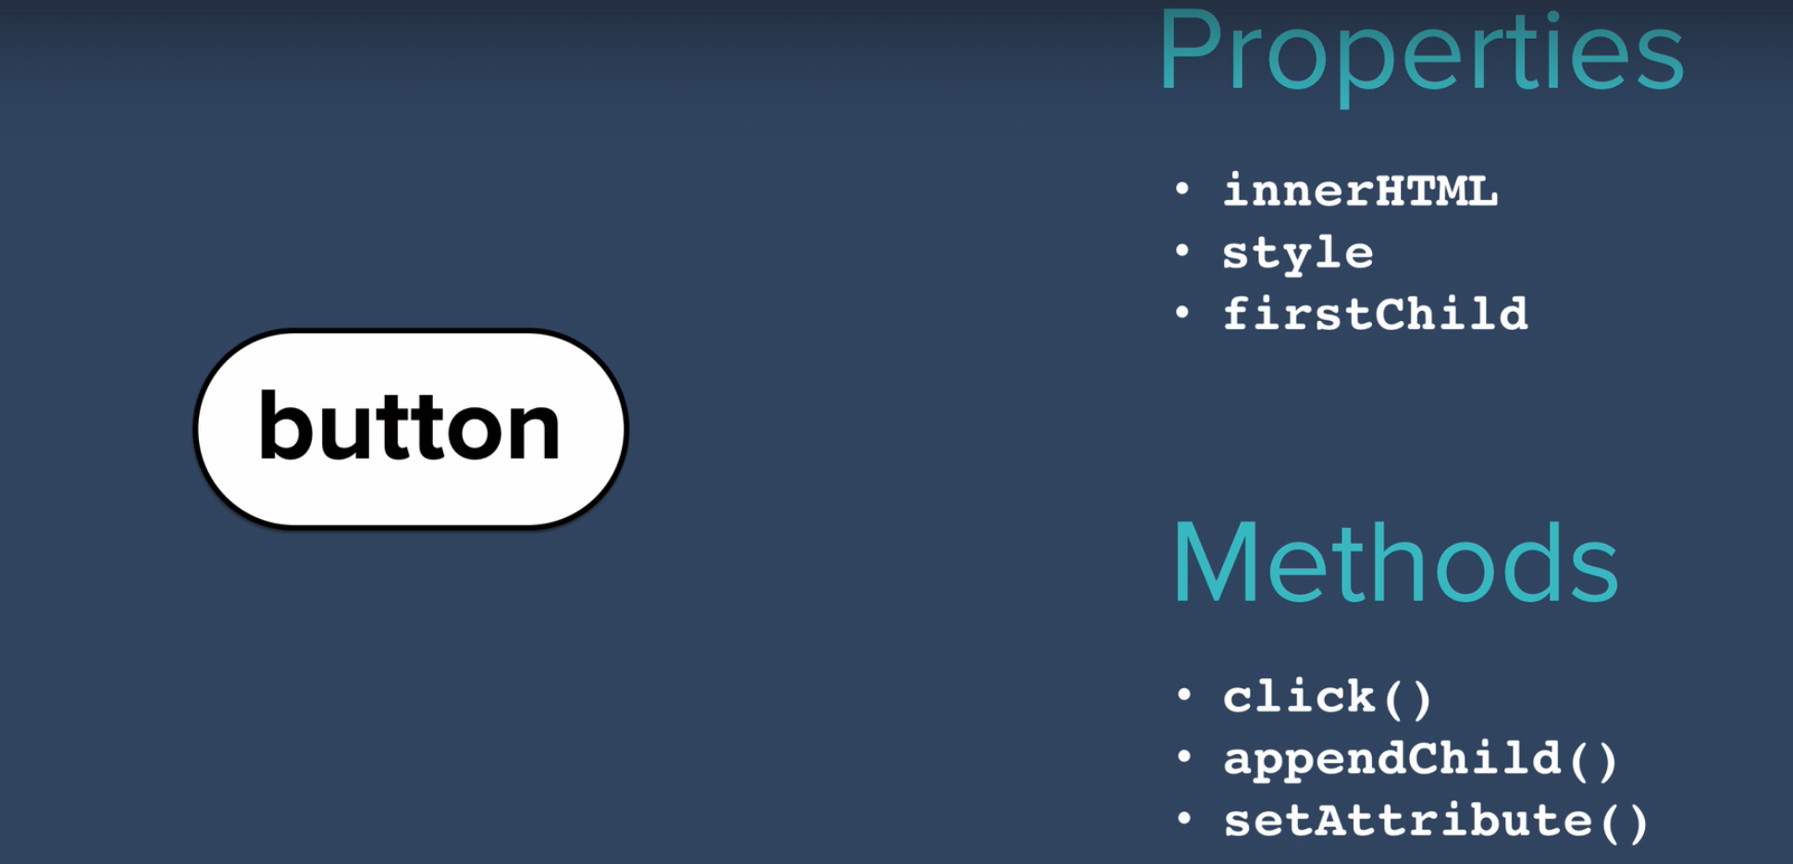

Changing the content of h1 in the given DOM

Var heading = document.firstElementChild.lastElementChild.firstElementChild;

Heading.innerHTML = “Good Bye”

Heading.style.color = red;

Document.querySelector(“input”).click();

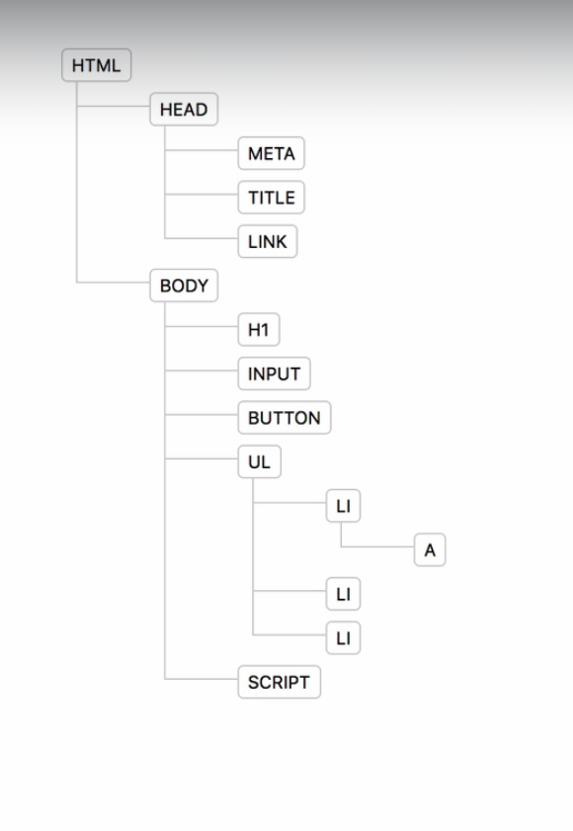

Selecting HTML elements using JavaScript

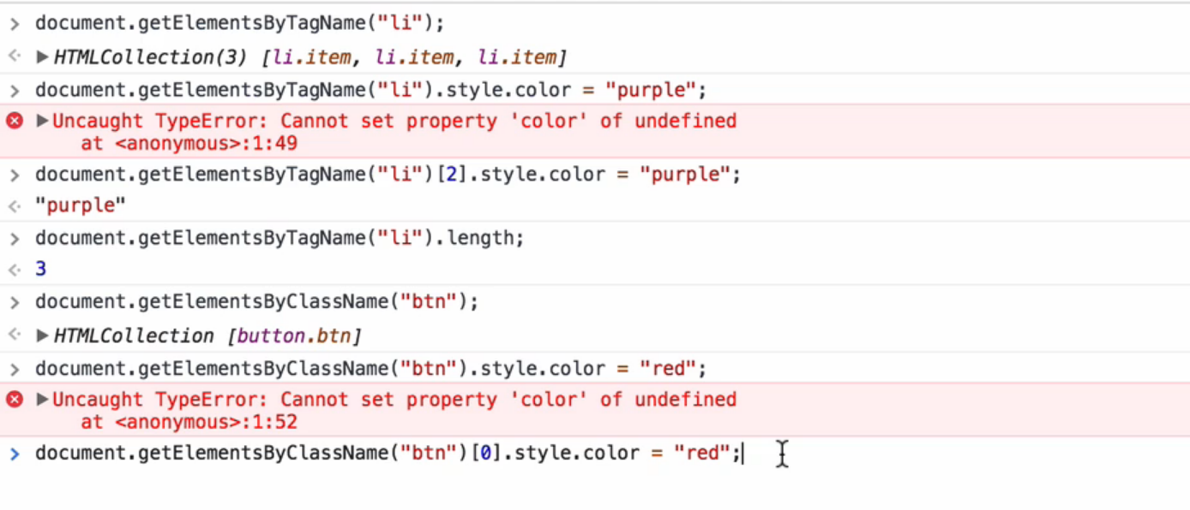

Note:

* document.getElementsBy… always return an array. So, to change the property of a particular element, we will have to select it using the subscript ‘[]’ operator.
* Exception:

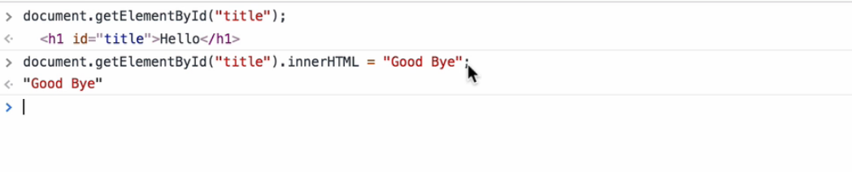

* It always select a single element as an id is unique in an HTML page.

Query Selector

Selects a single element using selectors (element, class or ID).

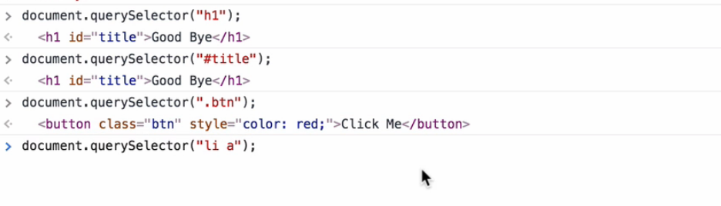

Note:

* While performing a query selector, if more than one element satisfy the condition, then the first element among them is selected by default.
* In such cases, to select all the elements satisfying the condition, use

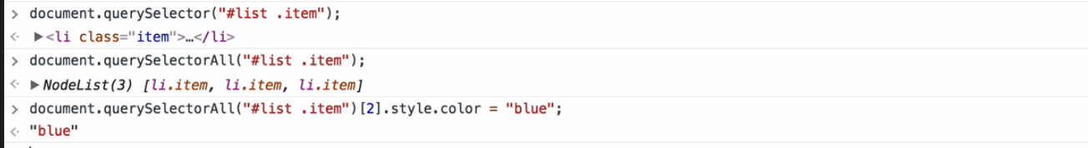

* Adding a class to the list/ array of elements having element as button.

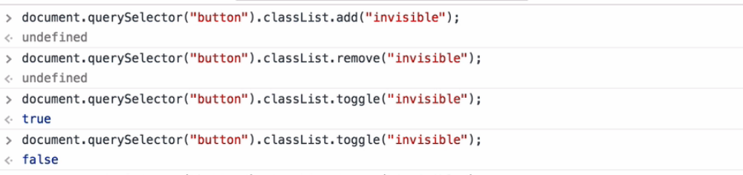

* Once, the class is added, we can style its behaviour in our stylesheet.

Text Manipulation and Text Content Property

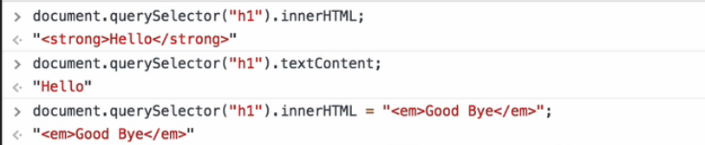

* querySelector(“h1”).innnerHTML select all the content inside the given selector.
* While, querySelector(“h1”).textContent selects only the text content inside the given selector.

Manipulating an HTML Attribute

* An HTML attribute is a modifier of an HTML element that provides additional information about how the element should behave or be displayed.
* Attributes are added to HTML elements in the form of name-value pairs, and appear within the element's opening tag.
* E.g., <a href="https://www.google.com"> Google</a>

Here, href="https://www.google.com"> is an attribute of the anchor tag used.

<h1 class="main-heading">....</h1>

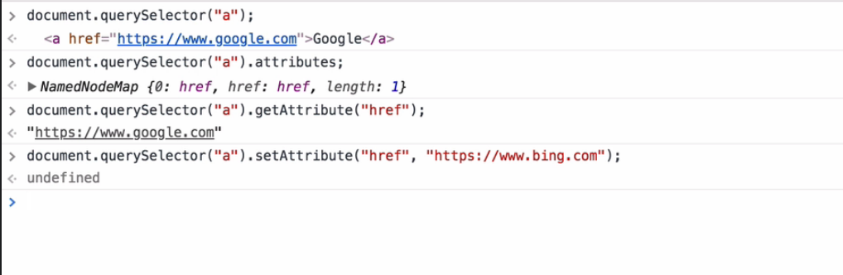

Event Listeners in JavaScript

* Event listeners in JavaScript are functions that can be attached to elements in an HTML document to respond to events such as a button click, a form submission, or a page load.
* They allow developers to make their web pages dynamic and interactive
* For Example:

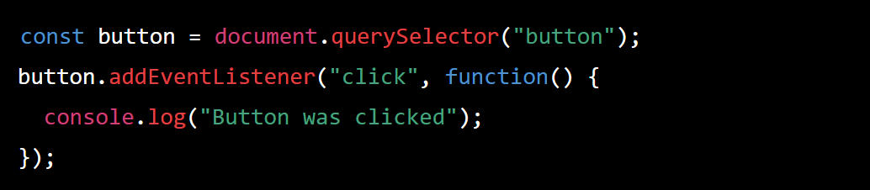

In this example, the querySelector method is used to select a button element on the page, and the addEventListener method is used to attach an event listener to it. The first argument to addEventListener is the type of event to listen for (in this case, a "click" event), and the second argument is the function to be called when the event occurs.

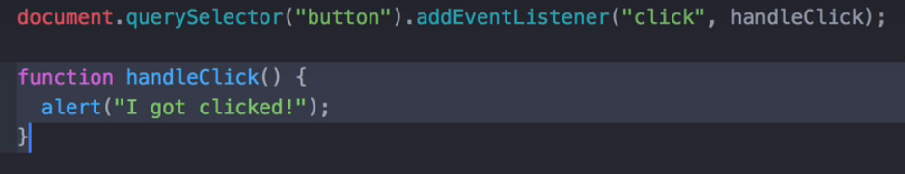

Here, the function handleClick gets triggered whenever the first button is clicked.

Note:

* Here, the parenthesis is not included in the function call. This is because in this case the function is passed as a input/ parameter so that it can be called at later stage.
* If we have include the parenthesis too, then the function gets executed straight away as soon as the browser interpret it.
* We have another method to implement such functionality, using anonymous functions (same as lambda function).

i.e., they don’t have name and they are defined at the place of function call itself.

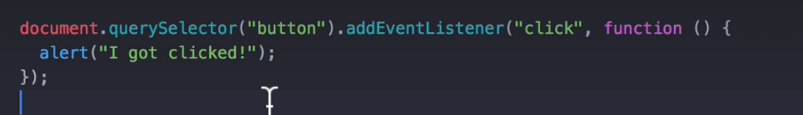

Passing Function as an argument

* The functions which take other functions as an argument are known as higher order functions.

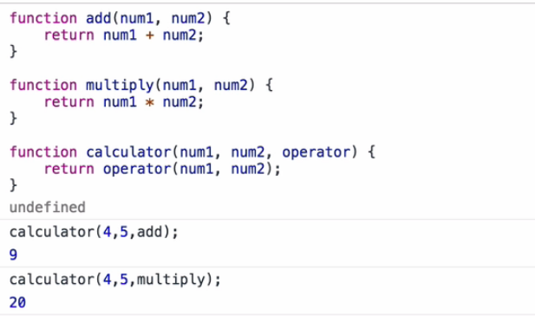

Note:

* ‘this’ object can be used to find the button which triggers the event.
* Changing the colour of the button triggering the event to white.

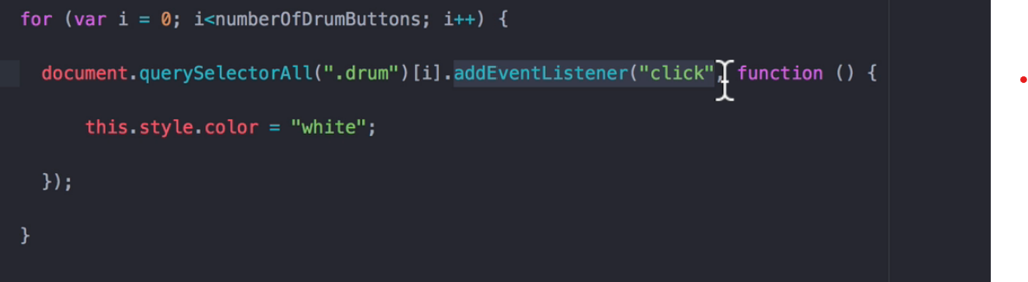

JavaScript Object

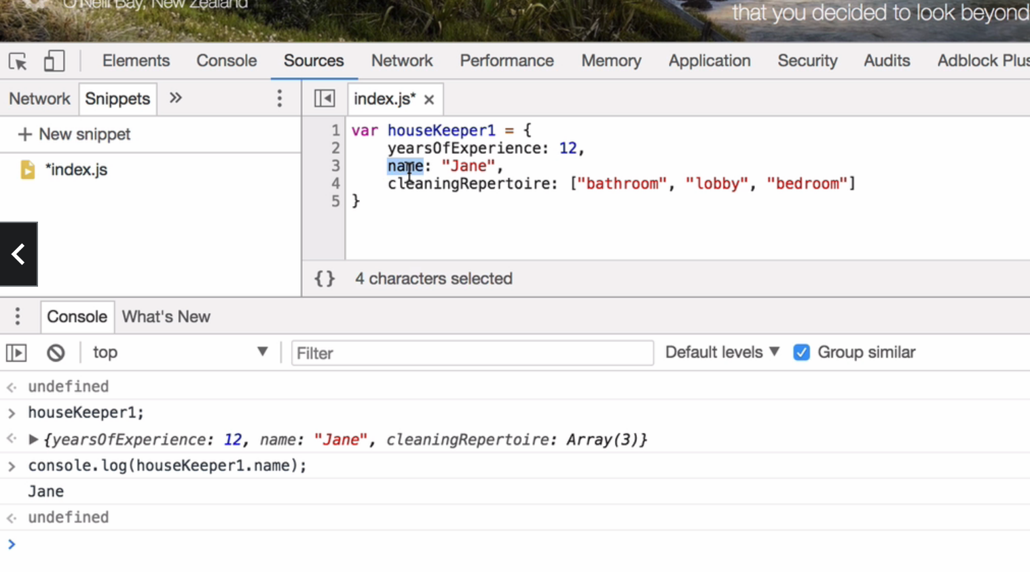

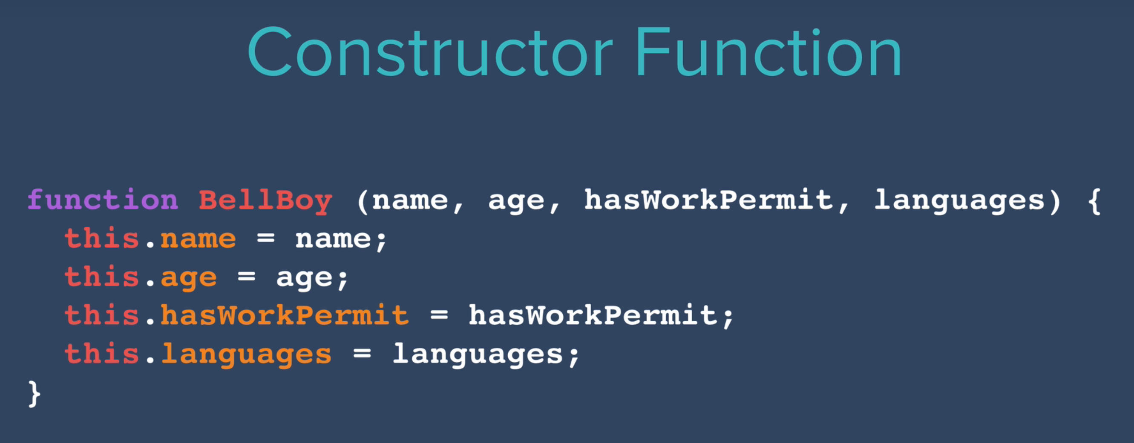

Initializing an object:



Note: The first letter of a constructor function is always Capital.

Methods/ Functions of an object

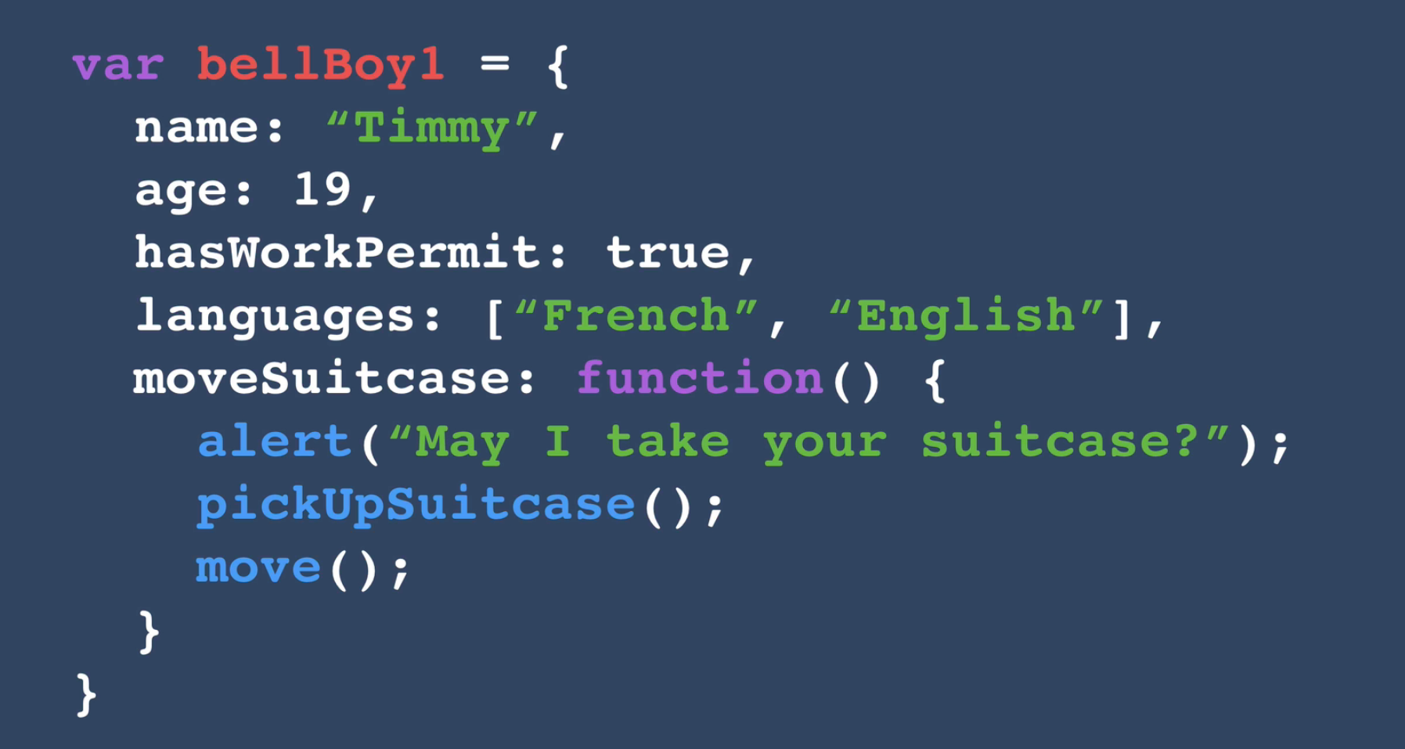

Calling the function: bellBoy1.moveSuitCase();

Callback Functions

* The functions that can be passed as input to a function are known as ‘Callback Functions’.
* It allows us to wait for something to finish happening.

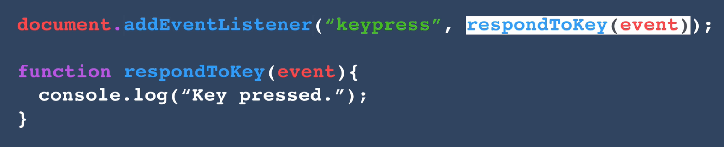

Getting the event that triggered the event:

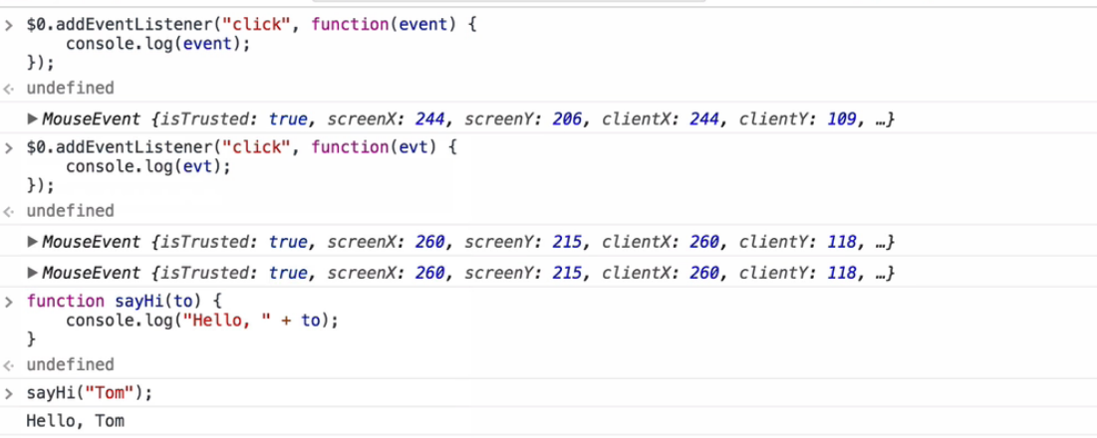

Callback functions are called by the objects that experience the event (click) and not by the user. And the user get to know about the event only after it had happened.

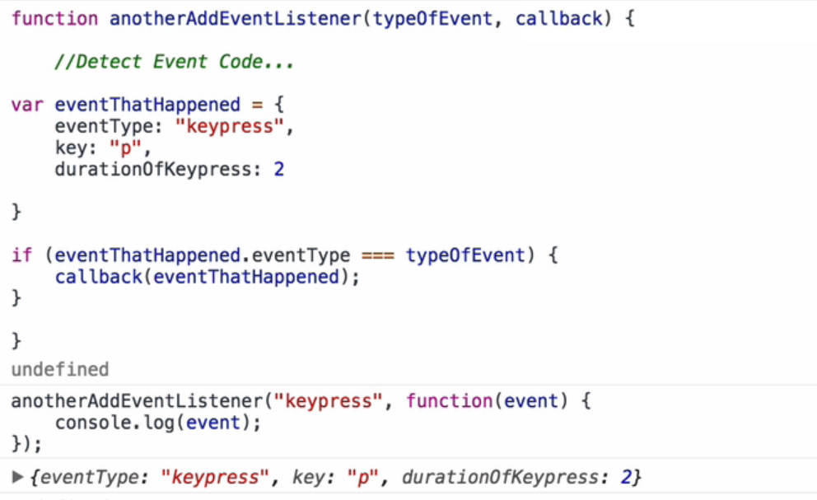

..

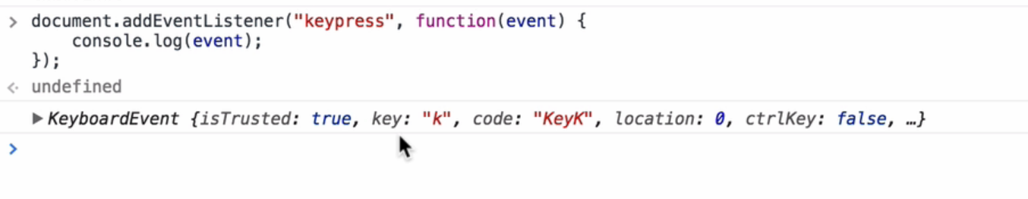

Adding Animation to our website

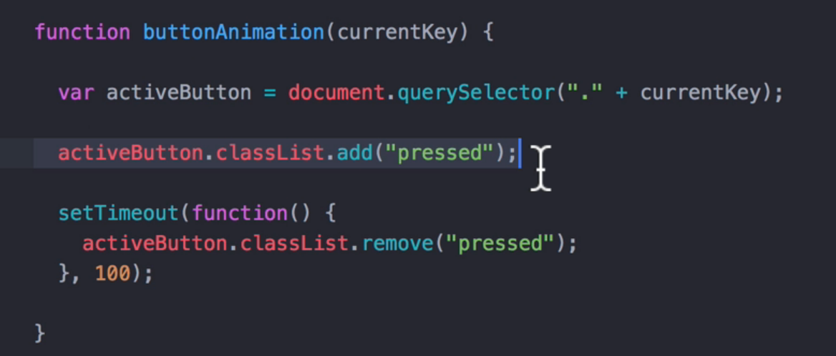

JavaScript Basics: Adiya Saini